Phase 9: Reports & Dashboards
Debug Log Analysis and Bug Fixing in Salesforce Apex

1. Objective of Phase 9
The purpose of this phase is to create reports and dashboards that provide insights into Apex execution, test results, and debugging activities.
Even though the primary focus of this project is Apex debugging, using reports and dashboards helps:
- Track test coverage and results.
- Visualize debug log trends or recurring issues.
- Demonstrate project functionality in a presentation-ready format.
- Evaluate the impact of fixes applied during debugging.

2. Reports for Debugging Insights
a. Apex Test Results Report
- Lists all executed test classes and their results.
- Fields included:
  - Test Class Name
  - Test Method Name
  - Status (Pass/Fail)
  - Execution Time
- Helps quickly identify failing tests and verify bug fixes.
b. Deployment & Metadata Status Report
- Tracks which Apex classes and components are deployed.
- Ensures that all deployed metadata is aligned with the Salesforce DX project.
c. Optional Debug Log Summary Report
- If debug logs are stored in a custom object (optional), reports can show:
  - Logs generated per user or session
  - Execution duration
  - Error occurrences

- 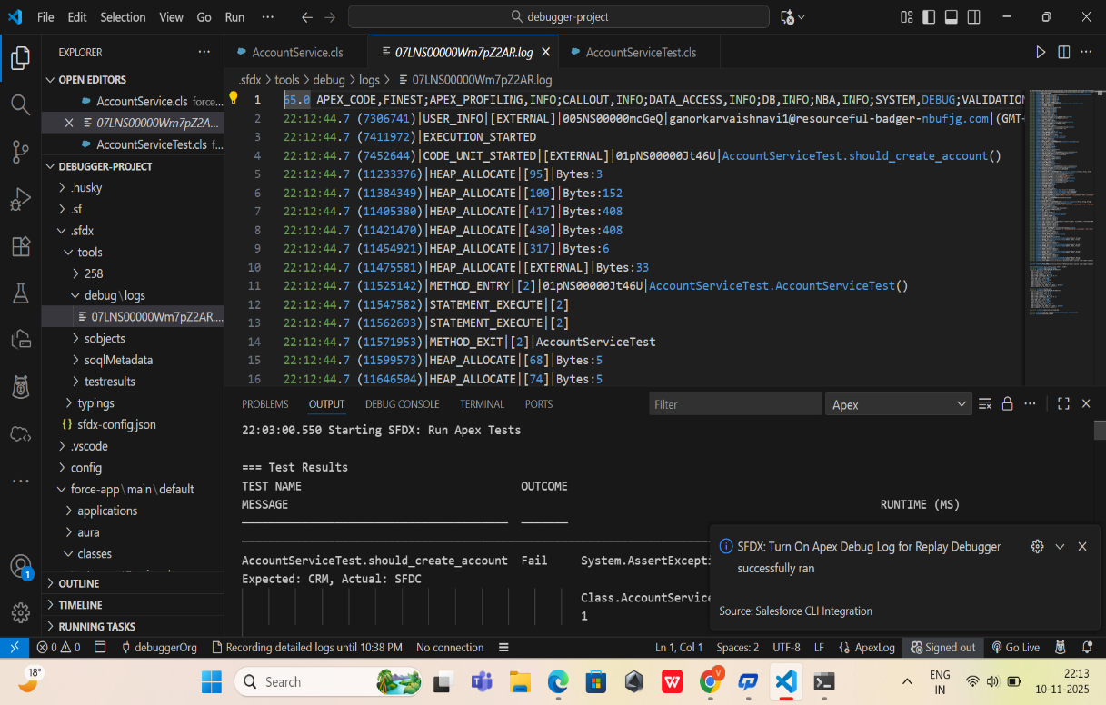

- 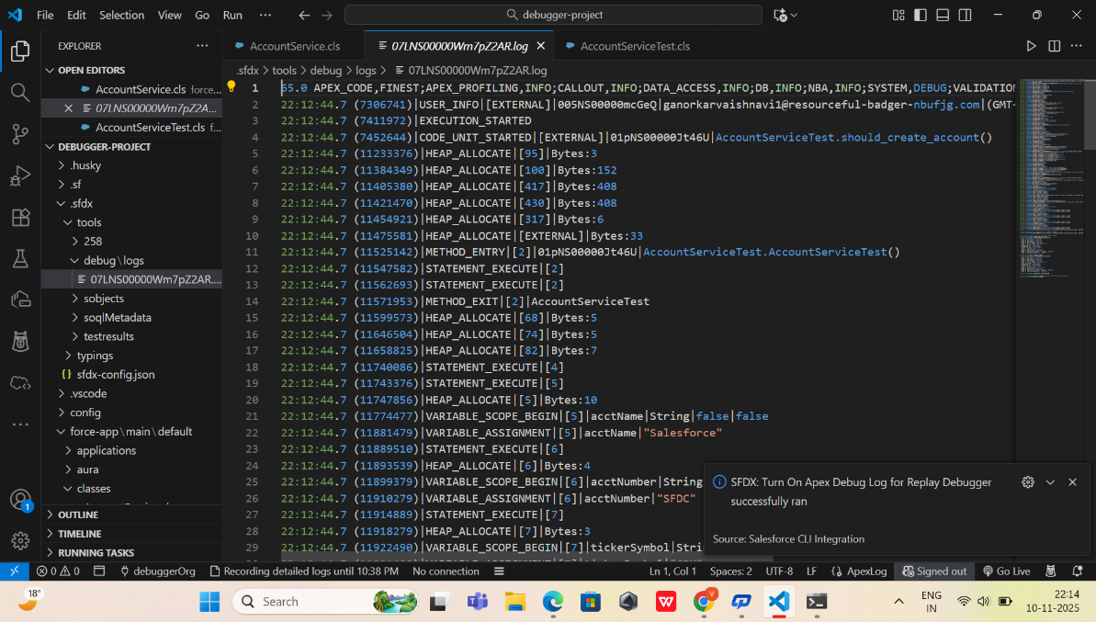

3. Dashboards for Visualization
Dashboards can provide graphical representation of the above reports:
- Test Execution Dashboard
  - Pie chart showing passed vs failed tests
  - Line chart showing test execution over time
- Bug Tracking Dashboard
  - Bar chart showing frequency of specific errors (e.g., TickerSymbol bug)
  - Helps visualize how fixes improve code quality
- Deployment Overview Dashboard
  - Visualizes which Apex classes and UI components are deployed successfully
  - Quick reference for project completeness

4. Benefits of Reports & Dashboards
- Provides a visual summary of testing and debugging efforts.
- Helps track progress after applying fixes.
- Useful for project presentation and demonstrating workflow.
- Supports decision-making for future improvements in Apex code.

5. Deliverables of Phase 9
By the end of this phase, you will have:
✔ Reports showing Apex test results and execution details
✔ Dashboards visualizing test pass/fail statistics
✔ Optional reports for debug log insights
✔ Clear, presentation-ready summary of project debugging activities

6. Outcome
- Provides a complete end-to-end view of Apex code testing and debugging.
- Demonstrates impact of debugging on Apex test results.
- Enhances the overall professional presentation of the Salesforce DX project.

